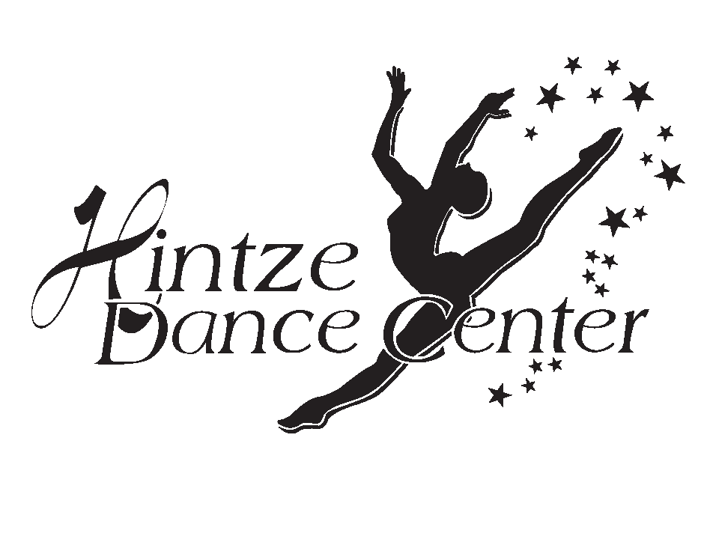
Hintze Dance Fry Road

9212 Fry Rd. #130
Cypress, Tx 77433

Class Schedule Summer 2021
Session 1 June14-0June 29 2021
(Closed July 5th-8th)

www.hintzedance.com

Studio A Studio B

All Classes require a minimum of 8 students

Tuesday

5:15-6:00: Ballet/Tap Kinder-2nd KM  6:00-6:30 Hip Hop Kinder -2nd KM  6:30-7:15 Ballet/Tap age 4-5 KM | 5:00-6:00 Ballet I-II GH  6:00-6:45 Leaps and Turns I-II GH

Wednesday

5:30-6:15 Beg Jazz 5-7yrs KM  6:15-7:00 Jazz 9-12yrs KM  7:00-7:45 Hip Hop 9-12yrs KM | 5:30-6:15 Beg, Lyrical 8-10 yrs KW  6:15-7:00 Jazz 8-10 yrs KW  7:00-8:00 . Drill Team Jazz KW  8:00-8:45 . Drill Team Leaps and Turns KW

Revised 4-18-18

